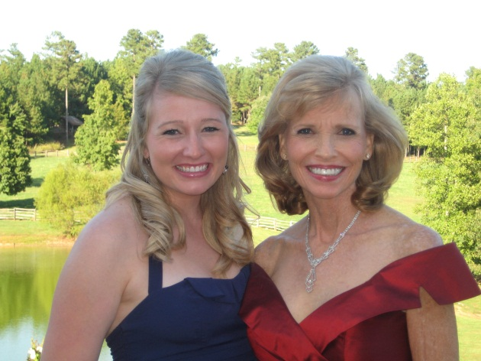

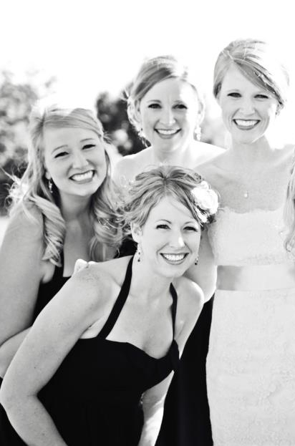

**Sisters**

|  |  |
| --- | --- |
| Some of My Favorite Things | |
| Salty Snack | **Pita Chips** |
| Sweet Snack | **Ice Cream** |
| TV Show | **FRIENDS** |
| Season | **Fall** |
| Holiday | **Christmas** |

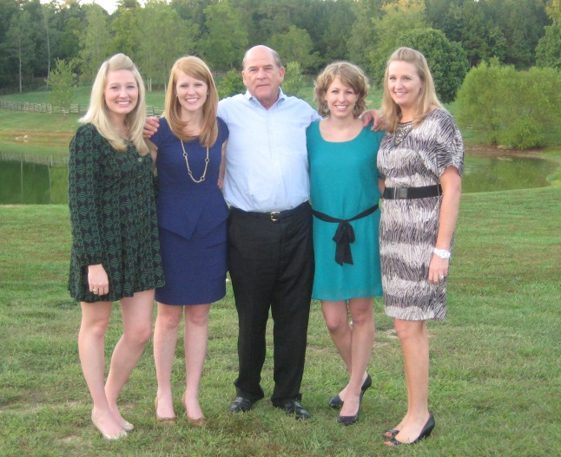

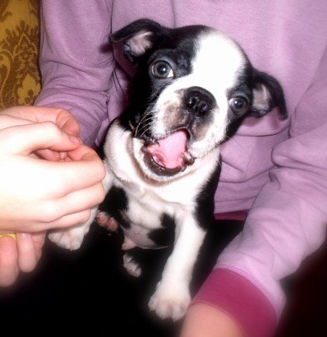

**My Boston Terrier, Cooper!**

Google images



Gig ‘Em, Aggies!

**FAMILY**

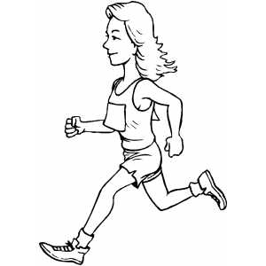

**½ Marathons**

Google images

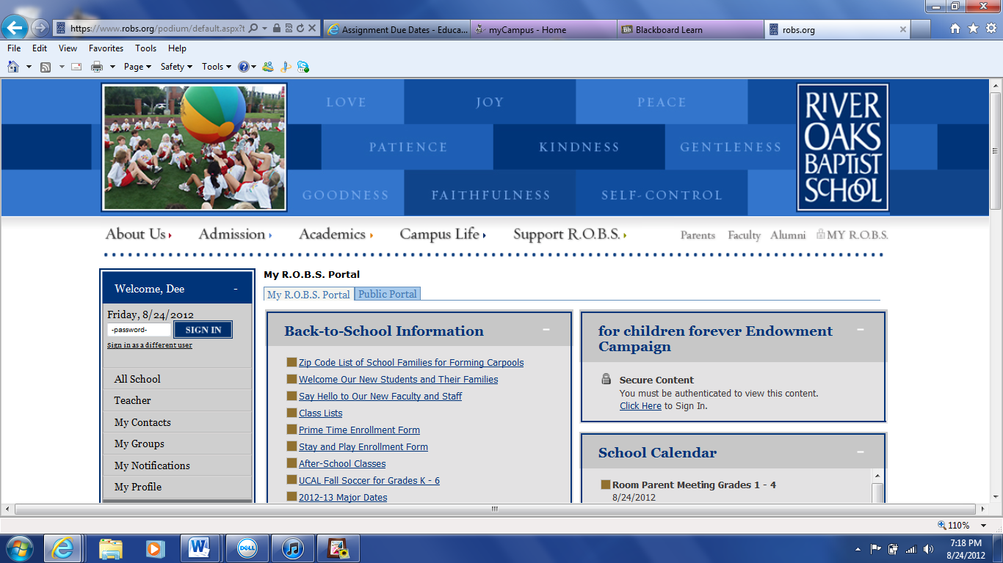

Courtesy of robs.org