The DDD-E Model
Lesson Title: Creating a Stop Motion Video
Targeted Grade Level: Fourth Grade
Subject: Technology in Mathematics
Lesson Objectives:
- The learner will strengthen his/her understanding of technology integration within the classroom.
- The learner will work with other students to become familiar with the Stop Motion app and understand how to create a stop motion video.
- The learner will create an original stop motion video with his/her group based on the steps of a math equation of his/her choice.
Standards:
Standard 1: Students demonstrate creative thinking, construct knowledge, and develop innovative products and processes using technology.
Standard 2: Students use digital media and environments to communicate and work collaboratively, including at a distance, to support individual learning and contribute to the learning of others.
Standard 4: Students use critical thinking skills to plan and conduct research, manage projects, solve problems, and make informed decisions using appropriate digital tools and resources.
Standard 5: Students understand human, cultural, and societal issues related to technology and practice legal and ethical behavior.
Standard 6: Students demonstrate a sound understanding of technology concepts, systems, and operations.

Materials/Resources Needed:
- One iPad per group (4-5 groups total)
- Stop Motion app loaded on iPad
- Dry erase boards and markers or magnetic numbers to write math equations/problems on
- Any other props students want to use in helping them create the math problem for their video
Lesson Components:
Focusing Event:
The teacher will guide students in understanding what a stop motion video is and open the lesson by showing a few examples. He/she will also explain why and how technology integration in various subjects can help with student understanding of concepts taught.
Instructional Handouts:
The following will be administered to the students throughout the project according to which phase they are working on.
- Flowchart and storyboard form to be completed during the Design phase (see forms attached)
- Checklist/timeline to guide students along in the project to be sure they have completed all components before turning finished product in (see checklist attached)
- Instructions on how to use Stop Motion for students to refer back to throughout the project (see instruction form attached)
Phase 1: Decide
- Once the teacher has put the students in groups of 3-4, students will need to determine the goals of their stop motion. They will need to ask each other questions like, What do we want to accomplish through this? What will help ensure that our video is effective and catchy?
- The students will then need to brainstorm the content their video will be comprised of. What math equation/problem will they focus on? Will it be lattice multiplication? Comparing fractions?
- Once the content that the video will include is decided, the group will need to conduct research on how to execute their plan. What items and props will they need to complete their video, and how best will they show the step by step process of solving the problem for their video?
Phase 2: Design
- The students will need to create a flowchart(s) to show the start to finish of their plan/math problem. What will happen first, next, etc.?
- Then, the group will need to specify the screen design. What will be in the background behind the dry erase board they are solving the problem on, if anything? Will each scene in the stop motion have the same background and screen design or will they be different?
- Next, the group will need to create a storyboard for their stop motion video. They will do this by filling in the storyboard outline handed out by the teacher (see attached) and drawing a rough sketch of what each scene will look like in their stop motion video.
Phase 3: Develop
- The first step of the development phase will be to create/add the audio that will be used. Will the students talk throughout the video walking the audience through each step of the math problem? Will there be background music instead and no talking? If music is used, will the students use the audio included with the app, or will they import a song from iTunes that they’ve downloaded separately?
- The second step will be to determine what graphics will be included in the video. Will there be drawn graphics or pictures imported from other places and then put into the video?
- The third step is the animation stage. Because this is a stop motion video, there will be animations throughout the video. That is the main idea of a stop motion – movement throughout.
- The next step of this phase will be to create the video. The students will need to work together to photograph each scene of the video with at least 10-12 frames each. The teacher will need to stress to the students the importance of shooting each shot with the iPad at the exact spot they shot the previous shot to avoid bouncing when the video is finished. The students might want to consider propping the iPad up on a stationary spot to avoid unnecessary movement.
- The final step in the development phase is for the group to author the program. This is the step when all of the above steps are combined and brought together. The audio, video, graphics and animations will all be part of the final stop motion. The students will likely need to do some editing throughout. For example, they may want to change some of the audio once they watch the video and see what it looks like all put together.
Phase 4: Evaluate
The evaluation process will include teacher evaluations of the students’ work as well as the students evaluating themselves and their peers.
The teacher should assess formatively by observing the students during the research and brainstorming phase along with providing students with feedback on their flowcharts and storyboards before they begin the development process. The teacher should also complete a summative assessment for the student using the stop motion project rubric (see rubric attached).
Students also need to participate in the assessment phase by completing a self-evaluation for their own contributions to the project (see attached) as well as completing a peer-evaluation to assess their peers’ contributions to the project (see attached).
Reflection:
Teacher spends time guiding students in the reflection process. A discussion will occur, and students should be given the opportunity to share their thoughts on the project; what they enjoyed most and what would be done differently next time.

Checklist for Stop Motion Video Project

(Check when completed)

Project goals have been discussed & defined _______

Group members have brainstormed content _______

Group members have conducted research on how video will be formatted _______

Flowchart(s) & Storyboard(s) have been completed _______

Screen Design has been discussed & planned out _______

Audio for video has been decided & planned out _______

Graphics for video has been decided & planned out _______

Animations for video have been decided & planned out _______

Video scenes have been shot & completed _______

Program has been authored by group members _______

Instructions for using Stop Motion App

- Once you are ready to start taking snapshots, open the app and position the camera in a stationary spot that it can stay for the entirety of the video making.
- Take the first picture of scene 1 (you will need to take 10-12 shots of each scene or copy and paste each scene to have a total of 10-12 frames each).
- Repeat step number 2 for each scene of the entire video. (You can watch the video at any time to see how it looks and to be sure it matches your vision for it)
- When all shots have been taken and video is put together, it is time to put additional graphics/animations/audio in.
- Using icons on the bottom of the screen, insert movie effects, audio and any additional text/slides with graphics.
- When video is finished, export video to dropbox or teacher’s email address.

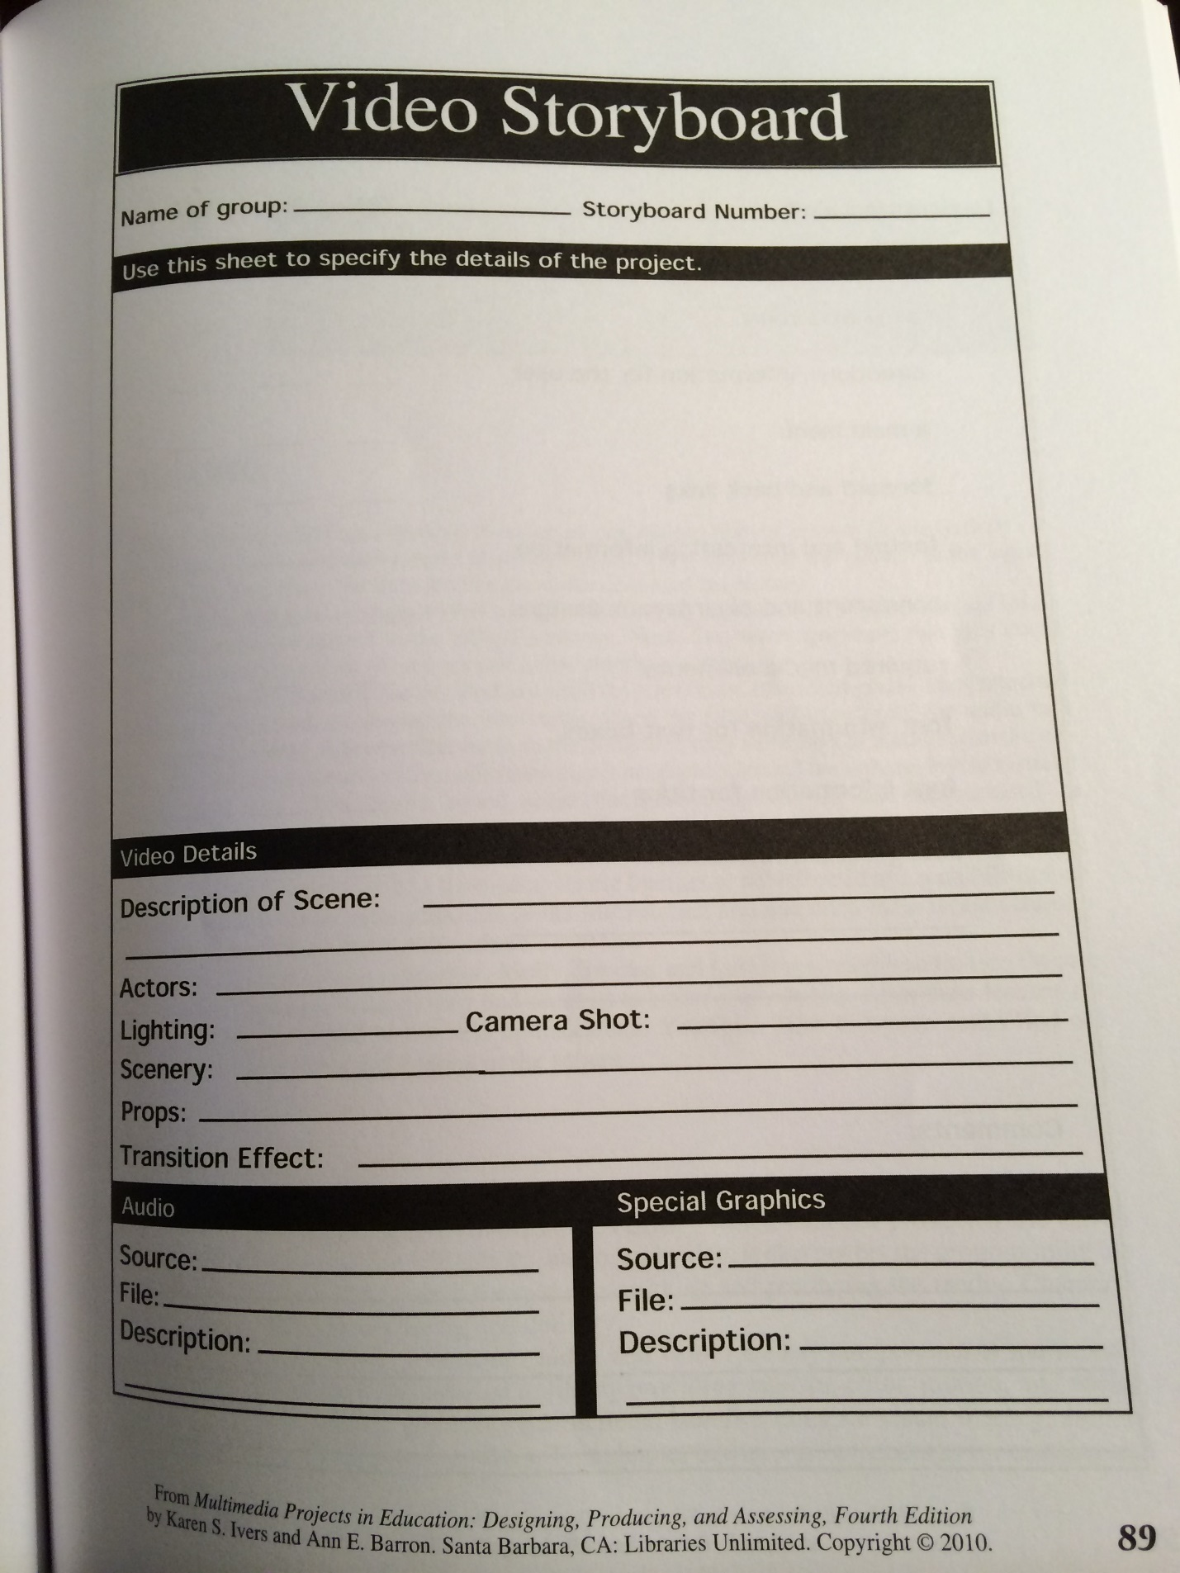
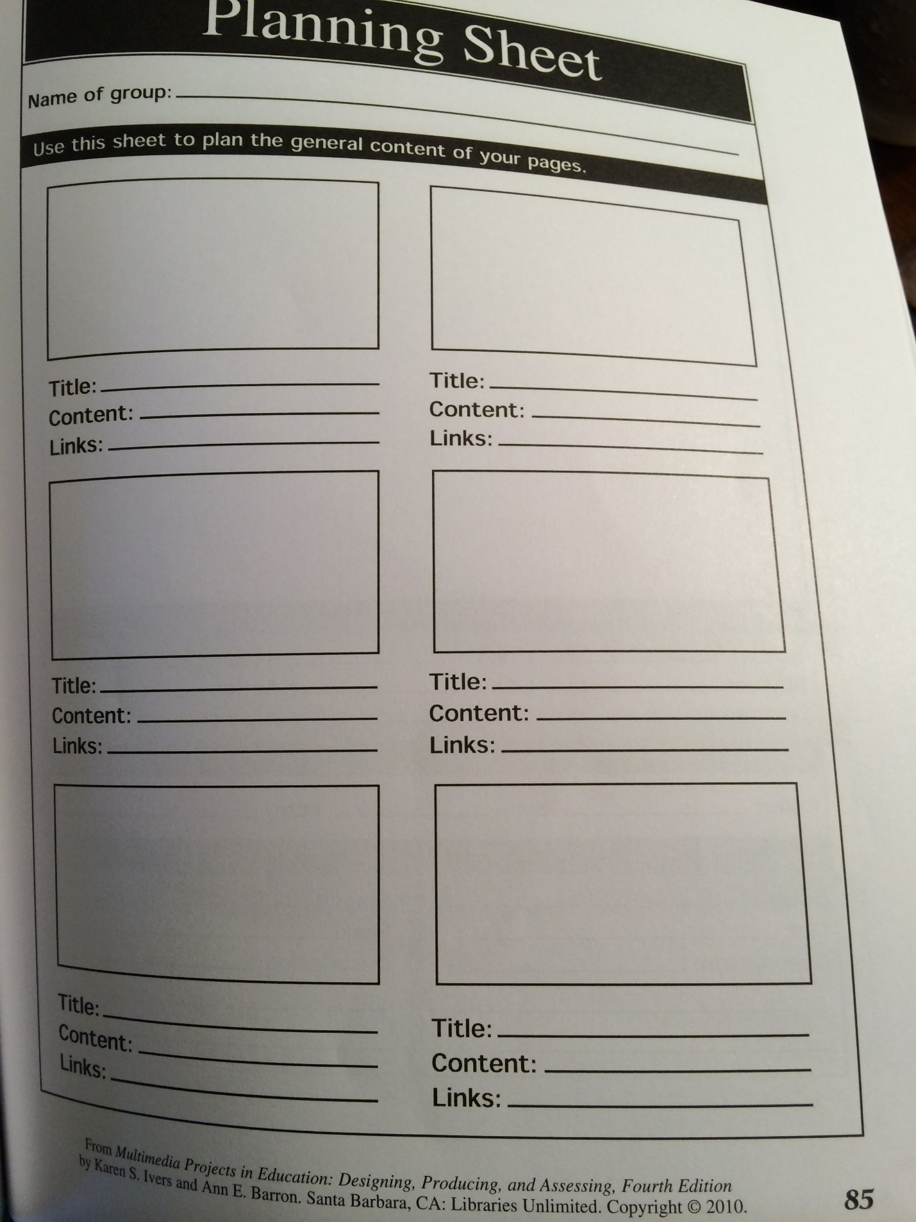
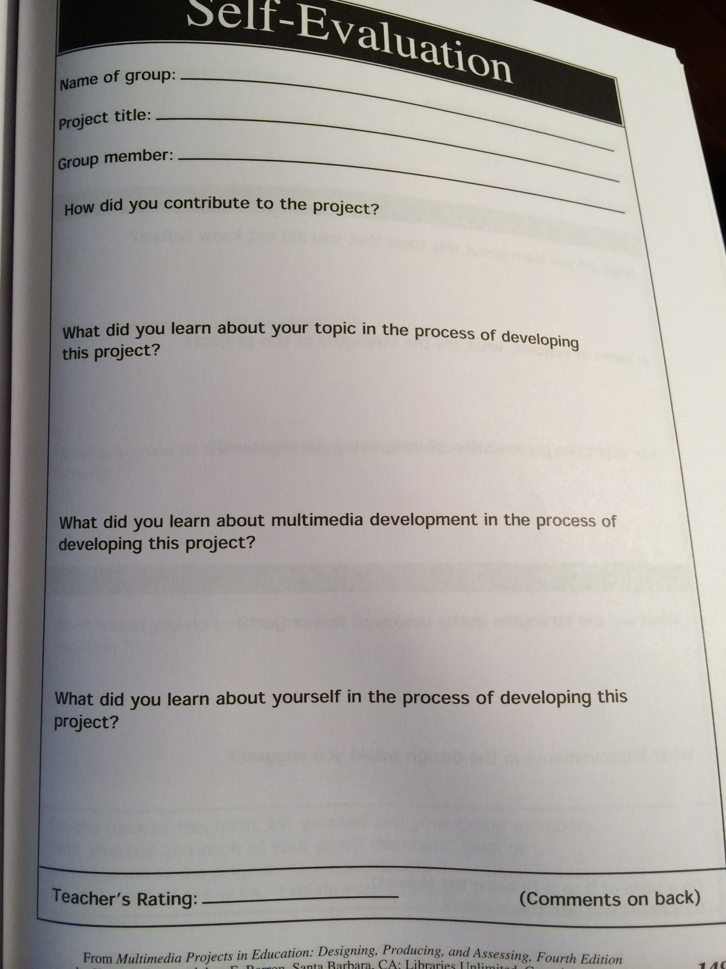
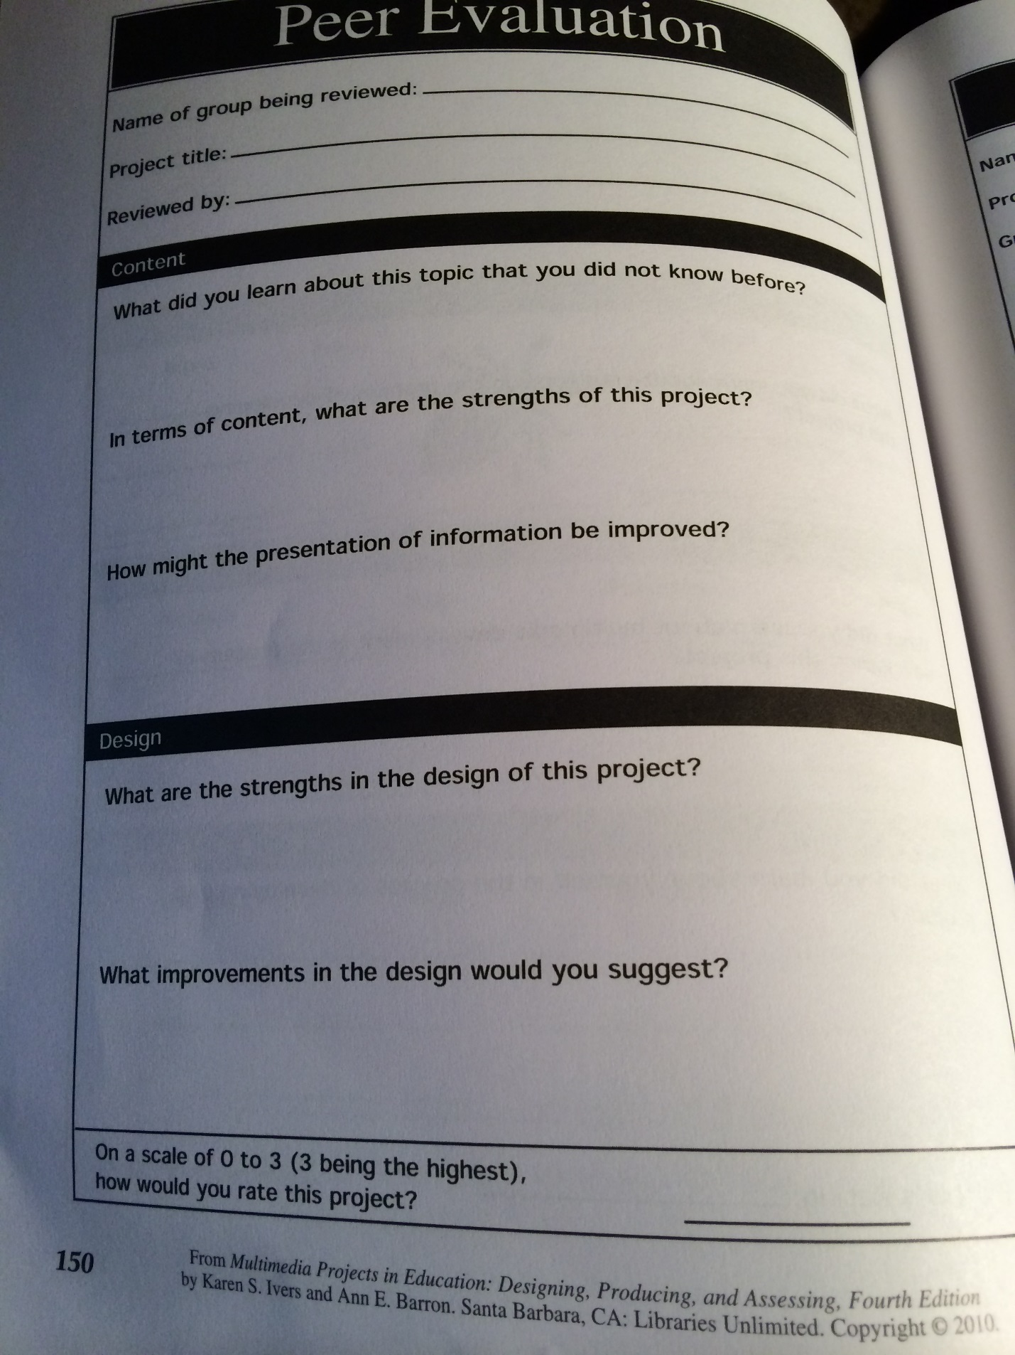

Criteria | 0  Beginning expectations | 1  Approaching expectations | 2  Meeting expectations | 3  Exceeding expectations
Flowchart/storyboard

Design

Content

Technical

Summative Assessment for Group
Student Names: _______________________________________________________________________

Total = _______

Summative Assessment for Individual
Student Name: _____________________

Criteria | 0  Beginning expectations | 1  Approaching expectations | 2  Meeting expectations | 3  Exceeding expectations
Effort

Contributions

Behavior

Total = _______

