Dee Moore – 9/25/12
The web 2.0 tool I chose is Wordsift. I like this tool, because it is used as a research device to help one turn text into visual definitions or representations. For my chosen unit that I will be teaching in 4th grade, European Explorers, I think Wordsift would be very useful for my students. One reason is because my students will have to have various pictures to accompany their report/presentation. The way I see them using it is researching the visuals and then moving those to a collage report to show the class, possibly through Microsoft Word.

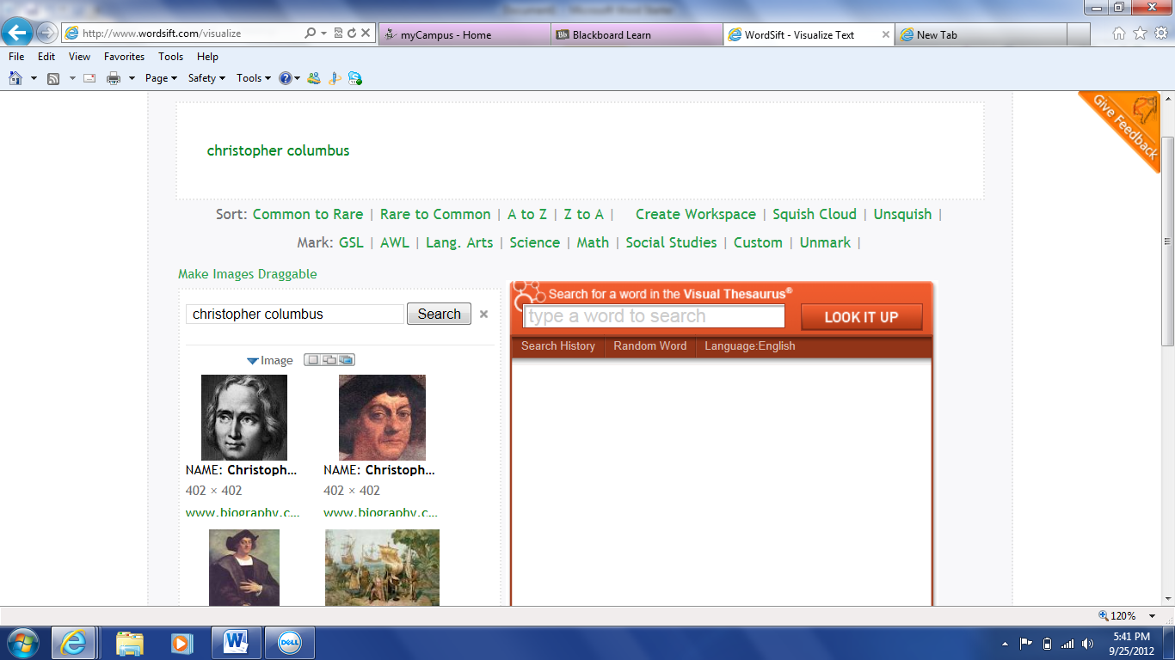

Tutorial:
-go to www.wordsift.com
- type in single word or multiple words into blank box and click sift
- select any visuals you like and by clicking it, you will be directed to the source website along with the picture
- you can save the pic to your desktop and insert it into another file/program you are working on/in

